**AWS For DevOps**

What is Cloud Computing

[**https://aws.amazon.com/what-is-cloud-computing/**](https://aws.amazon.com/what-is-cloud-computing/)

Cloud computing is the on-demand delivery of IT resources over the Internet with pay-as-you-go pricing. Instead of buying, owning, and maintaining physical data centers and servers, you can access technology services, such as computing power, storage, and databases, on an as-needed basis from a cloud provider like Amazon Web Services (AWS).

Cloud Computing video from Azure

<https://www.youtube.com/watch?v=txZrgdehLaw>

Who is using cloud computing?

Organizations of every type, size, and industry are using the cloud for a wide variety of use cases, such as data backup, disaster recovery, email, virtual desktops, software development and testing, big data analytics, and customer-facing web applications. For example, healthcare companies are using the cloud to develop more personalized treatments for patients. Financial services companies are using the cloud to power real-time fraud detection and prevention. And video game makers are using the cloud to deliver online games to millions of players around the world.

# Benefits of cloud computing

* Agility
* Elasticity
* Cost saving
* Deploy globally in minutes

# Types of cloud computing

* Infrastructure as a Service (IAAS)
* Platform as a Service (PAAS)
* Software as a Service (SAAS)

**Infrastructure as a Service (Iaas)**

Iaas is also known as Hardware as a Service (HaaS). It is one of the layers of the cloud computing platform. It allows customers to outsource their IT infrastructures such as servers, networking, processing, storage, virtual machines, and other resources. Customers access these resources on the Internet using a pay-as-per use model.

IaaS is offered in three models: public, private, and hybrid cloud. The private cloud implies that the infrastructure resides at the customer-premise. In the case of public cloud, it is located at the cloud computing platform vendor's data center, and the hybrid cloud is a combination of the two in which the customer selects the best of both public cloud or private cloud.

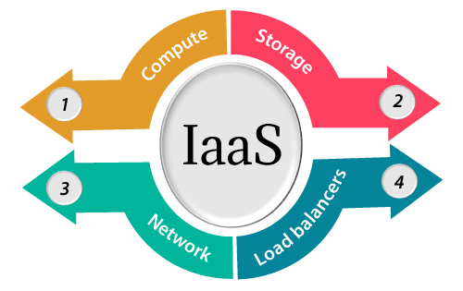

**Platform as a Service (PaaS)**

Platform as a service (PaaS) is a complete development and deployment environment in the cloud, with resources that enable you to deliver everything from simple cloud-based apps to sophisticated, cloud-enabled enterprise applications. You purchase the resources you need from a [cloud service provider](https://azure.microsoft.com/en-us/resources/cloud-computing-dictionary/choosing-a-cloud-service-provider/) on a pay-as-you-go basis and access them over a secure Internet connection.

Like [IaaS](https://azure.microsoft.com/en-us/resources/cloud-computing-dictionary/what-is-iaas/), PaaS includes infrastructure—servers, storage, and networking—but also middleware, development tools, business intelligence (BI) services, database management systems, and more. PaaS is designed to support the complete web application lifecycle: building, testing, deploying, managing, and updating.

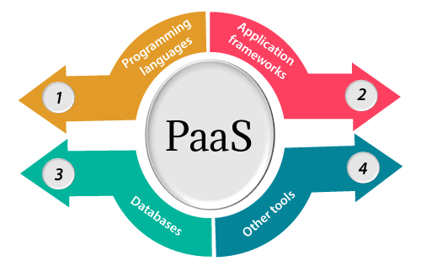

**Software as a Service (SaaS)**

Software as a service (SaaS) allows users to connect to and use cloud-based apps over the Internet. Common examples are email, calendaring, and office tools (such as Microsoft Office 365).

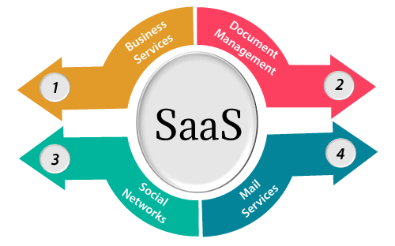

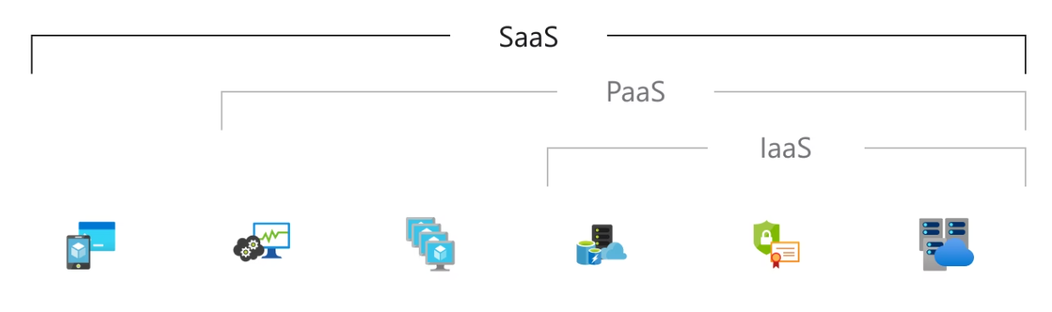

**TOP Cloud Providers**

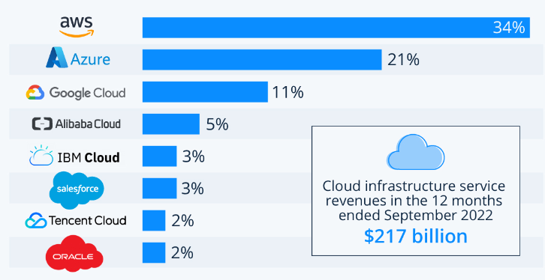

**AWS Global Infrastructure**

The AWS Cloud spans **96** Availability Zones within **30** geographic regions around the world, with announced plans for **15** more Availability Zones and **5** more AWS Regions in Australia, Canada, Israel, New Zealand, and Thailand.

<https://aws.amazon.com/about-aws/global-infrastructure/>

**Regions, Availability Zones, Edge Locations**

**Regions**

* **Regions are Large geographic areas**

**Availability Zones**

* **Datacenters**

**Edge Locations**

* **Edge locations allows users to access content with lower latency**
* **A site that CloudFront uses to cache copies of your content for faster delivery to users at any location**

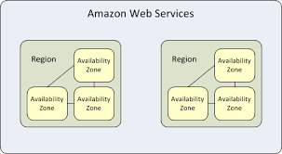

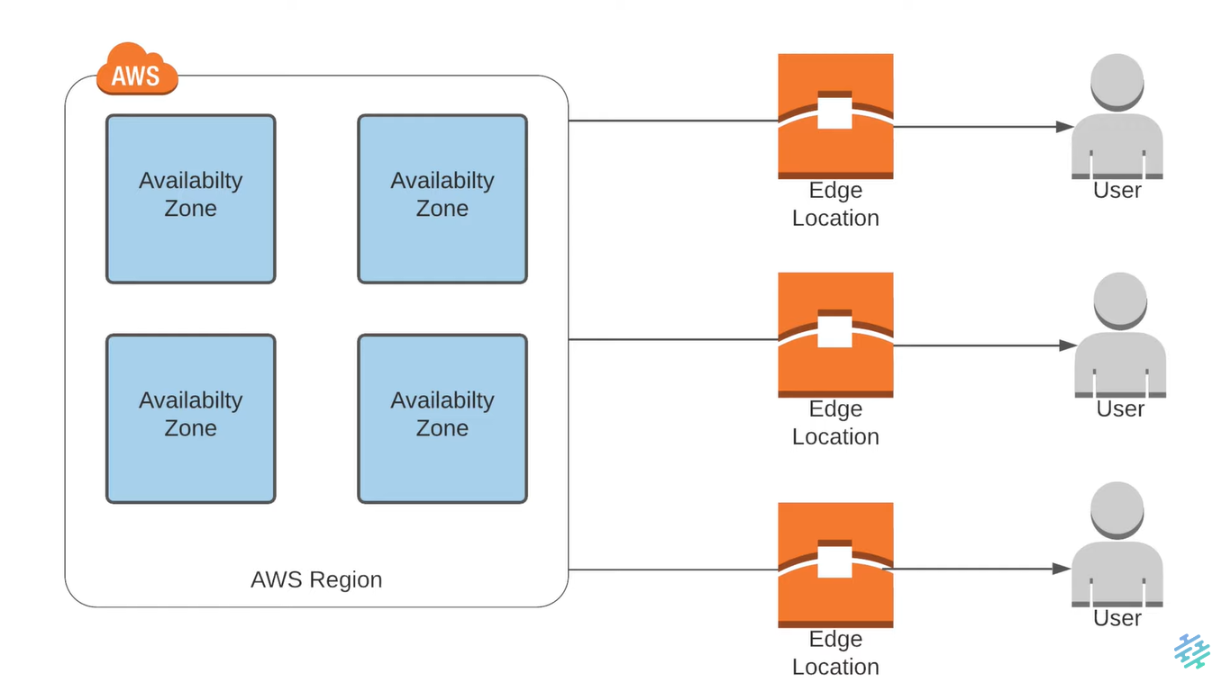

EC2 Instance

**Best Practices:**

* Gather the requirement
* Create the Key pairs
* Create the Security Groups
* Launch Instance

**Gather Requirement:**

1. Operating System
   1. Ubuntu
   2. Centos
   3. Etc
2. Size of RAM, CPU, Network Etc
3. Storage size
   1. 10 Gig
4. Project Tag
5. Services/Apps will be Running
   1. SSH, HTTP, MySQL etc
6. Environment
   1. DEV, QA, Staging, Pre-Prod, Prod
7. Login user/owner

**Setup a Website on EC2 Instance**

* Go to tooplate.com
* Create a Key Pair for this project – Give name as “Nano-Dev”
* Select .pem format & Click Create Key pair
* Private key will be downloaded into your system and public key will be stored in the AWS Key Pairs section
* Go to “Security Groups” 🡪 Create Security Group 🡪 Give name as “Nano-Dev-SG”

**Security Group**

* Security Group is nothing but a virtual Firewall which will allow / deny the incoming and outgoing traffic

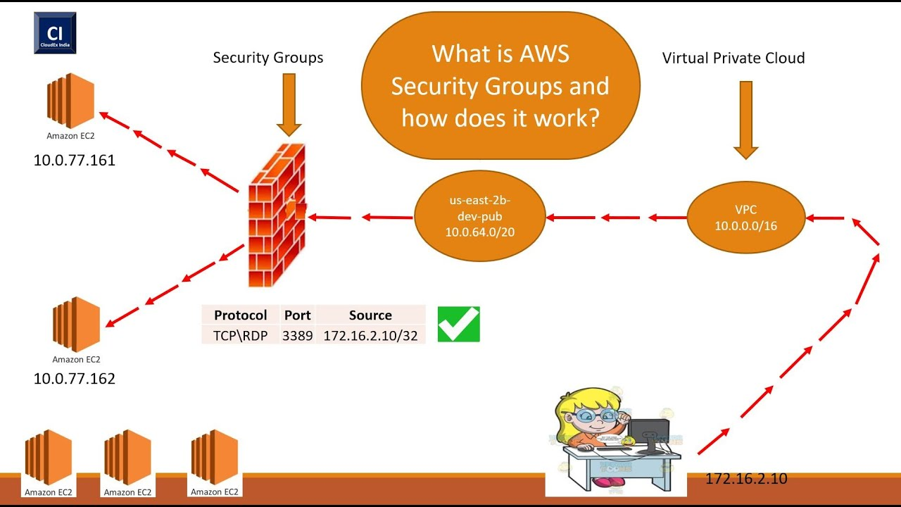

* Launch Instance 🡪 Add Tags for Application & for Project
* Select the AMI
* Select the Instance-type
* Select the Key-pair which we created
* Select the Security Group which we created
* Login to EC2 instance from GIT Bash
* Copy & paste the website.sh content into a shell file like – website.sh

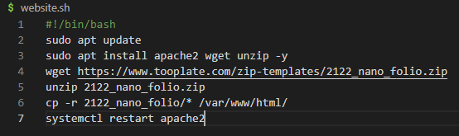

* Give it executable permission using **chmod +x website.sh** command
* Execute the shell script using “**sh website.sh or ./website.sh**” command
* Check the apache2 service using “**systemctl status apache2**”
* Allow port 80 from security group
* Now access the application using Browser

**More about EC2 Instance:**

* Stop and start the EC2 instance and check the public IP
* When you do this operation the Public IP will change. This is because AWS is assigning the Public IP from the pool. When you stop the Instance the IP will be released to the pool
* When you start the instance again, the public IP will be assigned again from the pool, but this time the IP will not be the same
* If you want to have fixed IP/Static IP then you have to use Elastic IP in AWS
* You will get 5 EIP by default by AWS, if you want more then you have to send request to the AWS support team and purchase more IP’s.
* Create a public IP, keep the same region name and click on Allocate.
  + Click on Actions
  + Click on “Associate Elastic IP address.
  + Choose the Instance and click on Associate
* Now Go to Instances
  + Select our Instance and Go to Actions tab
  + Settings
  + Change Instance Type
  + Before that you have to stop the Instance
  + Now you can change the instance type
* Network Interface
  + An elastic network interface is **a logical networking component in a VPC that represents a virtual network card.**
* Now go to Actions tab by selecting the Instance.
  + Select the Networking option
  + You will have options to Attach and Dettach to Network Interface
* Select Security in Actions tab
  + You can select different security group if you want to change the Security group

**AWS CLI**

<https://aws.amazon.com/cli/>

* Before using the AWS CLI, you should be installing the AWS CLI in your laptop
* You can below command to install AWS CLI
  + Open Powershell as Administrator
  + $ choco install awscli -y
  + If you have not installed Chocolaty in your windows laptop, you can install it using below link
  + <https://chocolatey.org/install>
  + You can check which version of aws cli has been installed
    - $ aws –version
  + Configure the AWS CLI on the laptop
  + Create an IAM User in AWS
    - Give name as “awscli”
    - Select Programmatic Access
    - Click Next
    - Attach policy – select “AdministratorAccess”
    - Next and create it
    - Download the .csv file
    - Now go to GIT Bash on your laptop
    - Run below command to configure using create user
      * $ aws configure
      * Copy & Paste the Access key and secret access key
      * Type the region name: “us-east-1”
      * Output format: json
      * Now it will create a hidden directory like : /.aws/
        + ls ~/.aws/
        + cat ~/.aws/config
        + cat ~/.aws/credentials
      * Run below command to check the configuration details
        + $ aws sts get-caller-identity
      * Run some commands like
        + $ aws ec2 describe-instances

<https://docs.aws.amazon.com/cli/latest/reference/>